Exno 1 d) Develop a web page to create registration page using html form tags.
Aim: Develop a web page to create registration page using html form tags. The tentative registration page template is given below. Your page should include,
- Use table to create forms with proper alignment.
- Apply different html input types (text, number, checkbox, radio and so on)
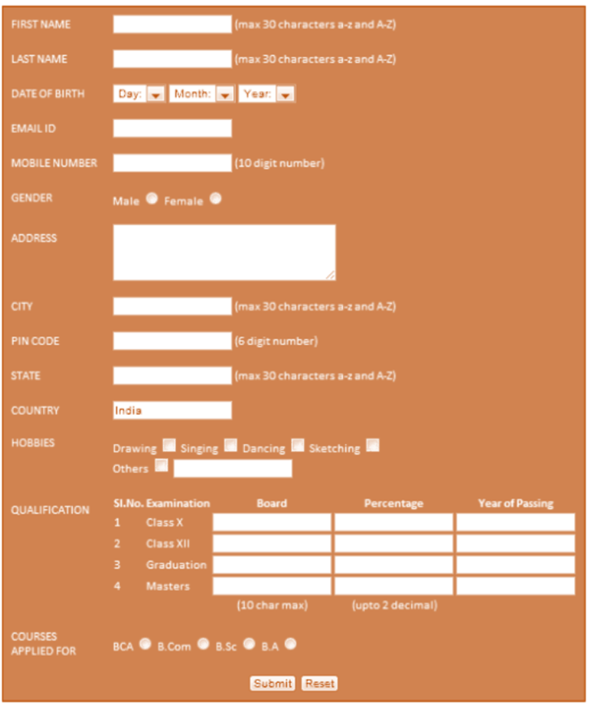
(Reference: progmgpalace)
HTML Tags need to be used:
Tags/elements/methods used | Attributes
<br>
<h1>
<p>
<table> | Use rowspan and colspan
<form>
<input> | Use different types
HTTP methods | get, post
<label>

Procedure:
- Create an html file named as registration.html to design a page as per the above-mentioned template.
- Multiple pages can also be created and connected together using form actions.
- Use HTTP methods (get and post) to understand the differences between them.
- In notepad or any editor or IDE type the necessary code & save with the file name mentioned with .html extension display your time table.
- To view your web page, simply double click your html file.

<Paste your code>
<!DOCTYPE html>
<html lang="en">
<head>
<title>Registration</title>
</head>
<body style="background-color: coral; font-family: Arial, sans-serif;">
<h1 align="center">Forms</h1>
<table align="center">
<tbody style="color: white;">
<form action="profile.html" method="post">
<tr>
<td style="text-align: left; padding: 10px;"><label for="fName">FIRST NAME:</label></td>
<td style="padding: 10px;">
<input type="text" id="fName" name="fName" maxlength="30"> (max 30 characters a-z and A-Z)
</td>
</tr>
<tr>
<td style="text-align: left; padding: 10px;"><label for="lName">LAST NAME:</label></td>
<td style="padding: 10px;">
<input type="text" id="lName" name="lName" maxlength="30"> (max 30 characters a-z and A-Z)
</td>
</tr>
<tr>
<td style="text-align:left; padding: 10px;"><label for="dob">DATE OF BIRTH:</label></td>
<td style="padding: 10px;">
<input type="date" id="dob" name="dob">
</td>
</tr>
<tr>
<td style="text-align: left; padding: 10px;"><label for="Email">EMAIL ID:</label></td>
<td style="padding: 10px;">
<input type="email" id="Email" name="Email">
</td>
</tr>
<tr>
<td style="text-align: left; padding: 10px;"><label for="number">MOBILE NUMBER:</label></td>
<td style="padding: 10px;">
<input type="tel" id="number" name="number" maxlength="10"> (10 digit number)
</td>
</tr>
<tr>
<td style="text-align: left; padding: 10px;"><label for="gender">GENDER:</label></td>
<td style="padding: 10px;">
Male <input type="radio" id="genderMale" name="gender">
Female <input type="radio" id="genderFemale" name="gender">
</td>
</tr>
<tr>
<td style="text-align: left; padding: 10px;"><label for="address">ADDRESS:</label></td>
<td style="padding: 10px;">
<textarea id="address" name="address" cols="35" rows="5"></textarea>
</td>
</tr>
<tr>
<td style="text-align: left; padding: 10px;"><label for="city">CITY:</label></td>
<td style="padding: 10px;">
<input type="text" id="city" name="city" maxlength="30"> (max 30 characters a-z and A-Z)
</td>
</tr>
<tr>
<td style="text-align: left; padding: 10px;"><label for="pincode">PINCODE:</label></td>
<td style="padding: 10px;">
<input type="text" id="pincode" name="pincode" maxlength="6" width="30px"> (6 digit number)
</td>
</tr>
<tr>
<td style="text-align: left; padding: 10px;"><label for="state">STATE:</label></td>
<td style="padding: 10px;">
<input type="text" name="state" id="state" maxlength="30"> (max 30 characters a-z and A-Z)
</td>
</tr>
<tr>
<td style="text-align:left; padding: 10px;"><label for="country">COUNTRY:</label></td>
<td style="padding: 10px;">
<input type="text" id="country" name="country" value="India" readonly>
</td>
</tr>
<tr>
<td style="text-align: left; padding: 10px;"><label for="hobbies">HOBBIES:</label></td>
<td style="padding: 10px;">
<label for="drawing">Drawing</label>
<input type="checkbox" id="drawing" name="hobbies" value="Drawing">
<label for="singing">Singing</label>
<input type="checkbox" id="singing" name="hobbies" value="Singing">
<label for="dancing">Dancing</label>
<input type="checkbox" id="dancing" name="hobbies" value="Dancing">
<label for="sketching">Sketching</label>
<input type="checkbox" id="sketching" name="hobbies" value="Sketching">
<br>
<label for="otherHobby">Others</label>
<input type="checkbox" id="otherHobby" name="hobbies" value="Others">
<input type="text" name="otherHobbyText" id="otherHobbyText" placeholder="Specify other hobbies">
</td>
</tr>
<tr>
<td style=" padding: 10px;"><label for="qualify">QUALIFICATION:</label></td>
<td>
<table>
<tr>
<th>SI.No</th>
<th>Examination</th>
<th>Board</th>
<th>Percentage</th>
<th>Year of Passing</th>
</tr>
<tr>
<th>1</th>
<th align="left">Class X</th>
<th><input type="text" id="boardX" name="boardX"></th>
<th><input type="text" id="percentageX" name="percentageX"></th>
<th><input type="text" id="yearX" name="yearX"></th>
</tr>
<tr>
<th>2</th>
<th align="left">Class XII</th>
<th><input type="text" id="boardXII" name="boardXII"></th>
<th><input type="text" id="percentageXII" name="percentageXII"></th>
<th><input type="text" id="yearXII" name="yearXII"></th>
</tr>
<tr>
<th>3</th>
<th align="left">Graduation</th>
<th><input type="text" id="boardGrad" name="boardGrad"></th>
<th><input type="text" id="percentageGrad" name="percentageGrad"></th>
<th><input type="text" id="yearGrad" name="yearGrad"></th>
</tr>
<tr>
<th>4</th>
<th align="left">Masters</th>
<th><input type="text" id="boardMasters" name="boardMasters"></th>
<th><input type="text" id="percentageMasters" name="percentageMasters"></th>
<th><input type="text" id="yearMasters" name="yearMasters"></th>
</tr>
</table>
</td>
</tr>
<tr>
<td style=" padding: 10px;"><label for="course">COURSES <br>APPLIED FOR:</label></td>
<td style="padding: 10px;">
BCA <input type="radio" id="courseBCA" name="course">
B.Com <input type="radio" id="courseBCom" name="course">
B.Sc <input type="radio" id="courseBSc" name="course">
B.A <input type="radio" id="courseBA" name="course">
</td>
</tr>
<tr>
<td colspan="2" align="center">
<input type="submit" value="Submit">
<input type="reset" value="Reset">
</td>
</tr>
</form>
</tbody>
</table>
</body>
</html>

<Paste cropped output>
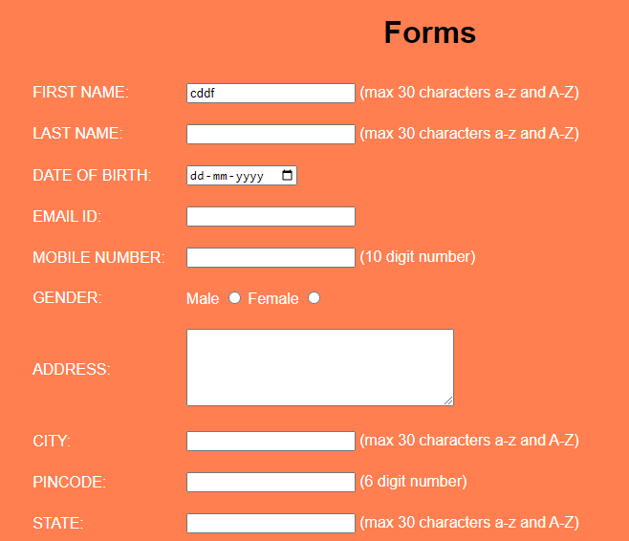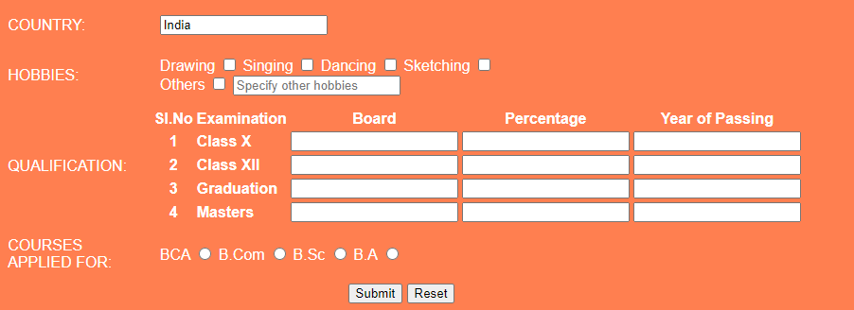

<Paste output screenshot with timestamp>
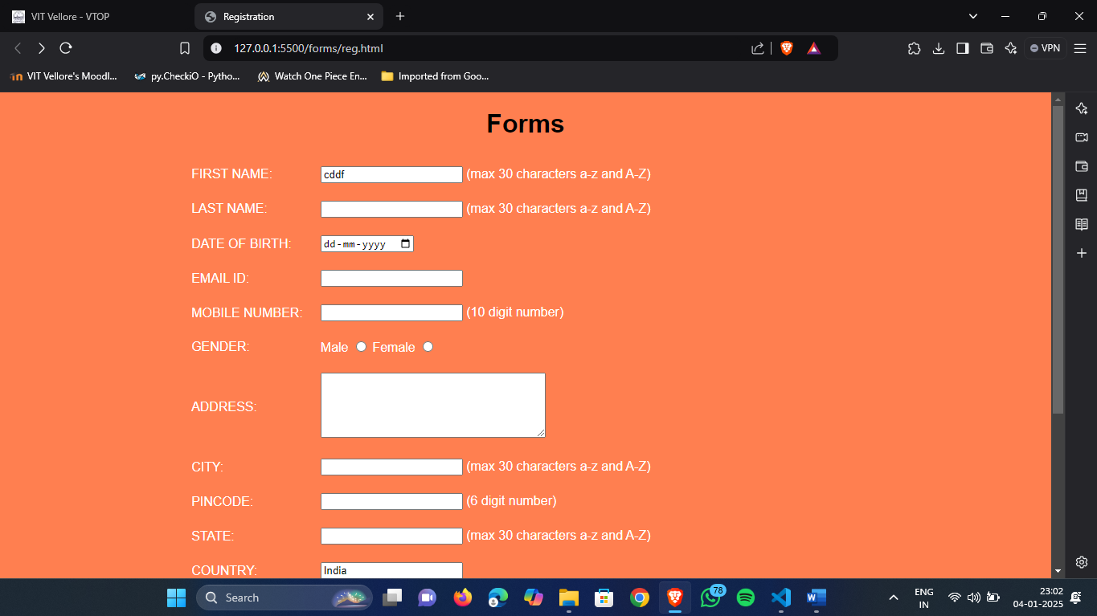
Result:
Thus a registration web page was created using basic html form and table tags. The output was verified.

